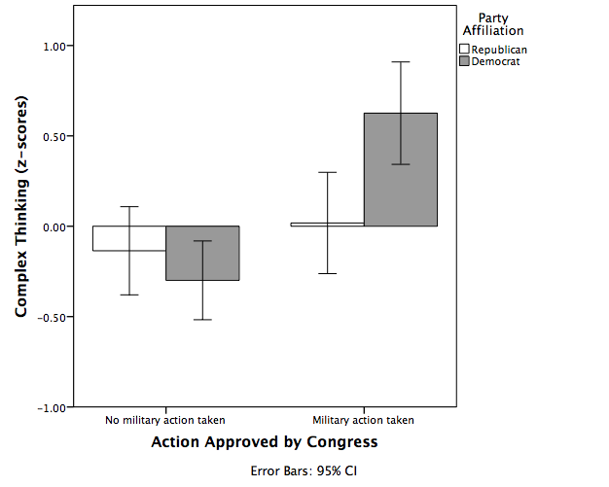

*Figure 4.* Interaction between party affiliation and action taken examining complex thinking for hypothesis 2.